Chargeable call flow

Machine status – Out of Warranty

Call type – Corrective Maintenance

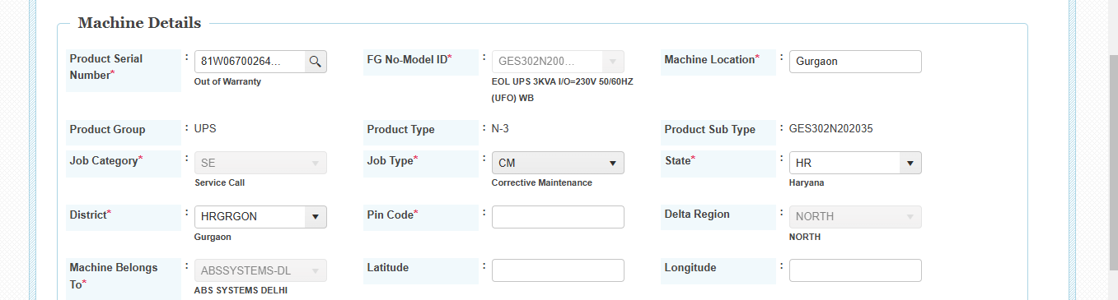L1 Logged the complaint.

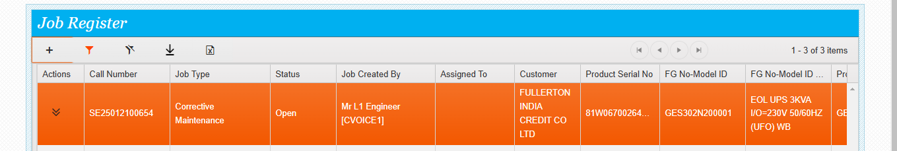Actions available for L1 (Assign to l2 support , Assign to Onsite support)

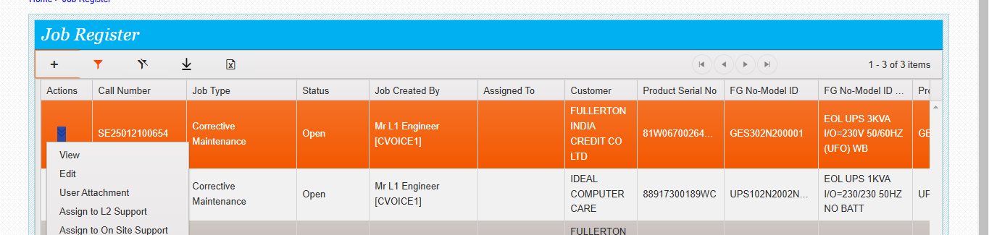When l1 support clicks Assign to onsite support directly the below screen will appear

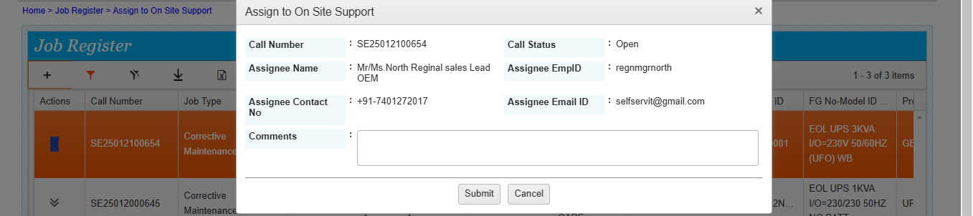

Chargeable call flow

When l1 support clicks Assign to l2 support then the below screen will appear

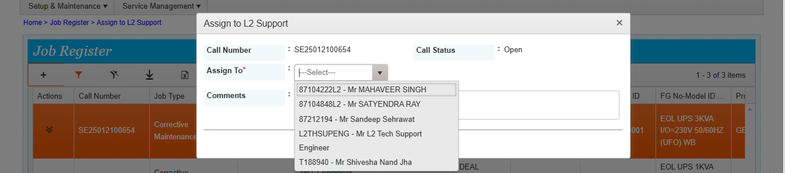If L1 support assign the call to l2 support 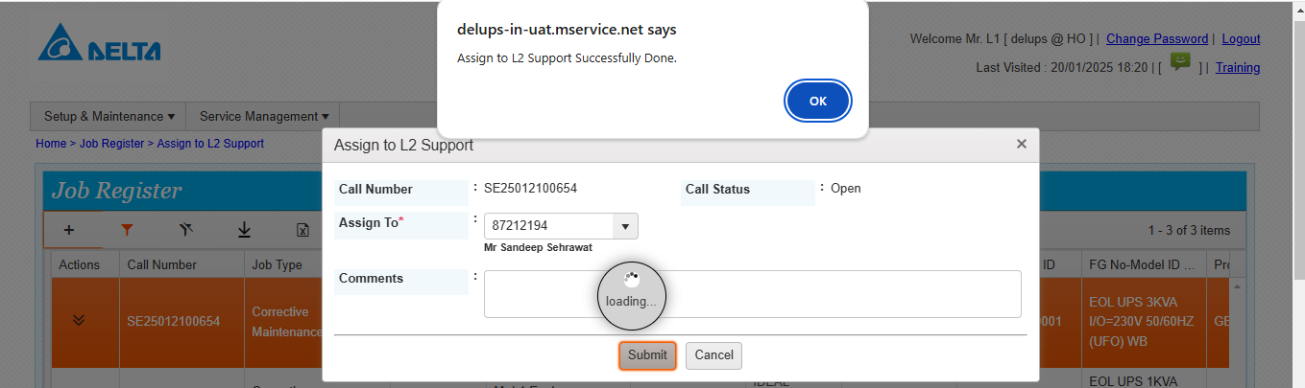L2 support can add the parts by doing the edit .

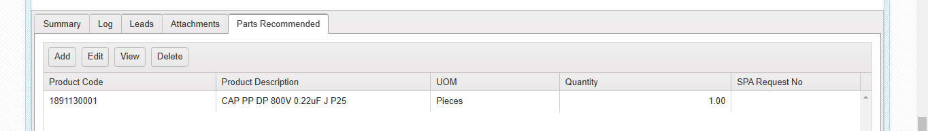From l2 Now the call is assigned to Onsite support. The below screen will appear

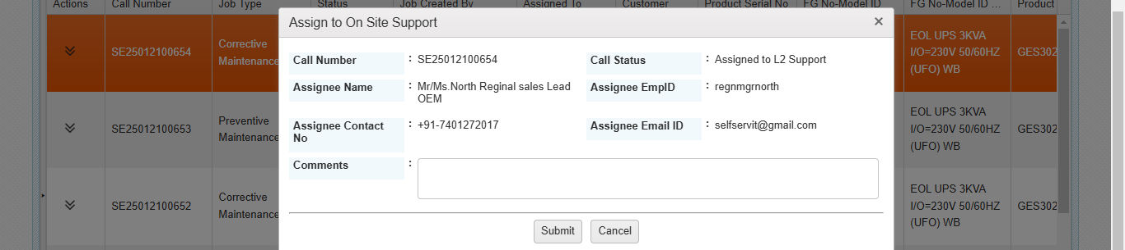

Chargeable call flow

Assign to Onsite support done (Assign to regional sales lead)

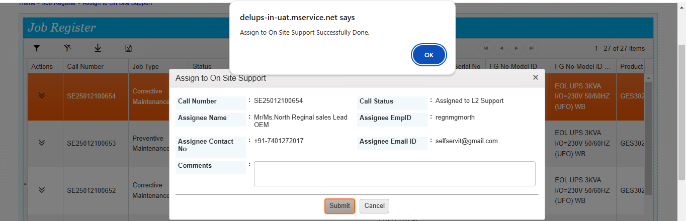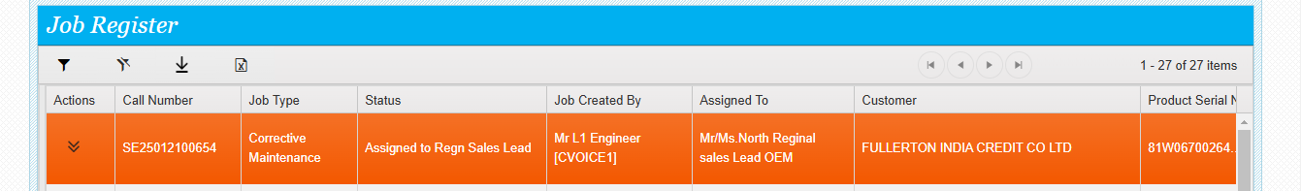Regional sales lead does the Login

And see the options available for the assigned service call.

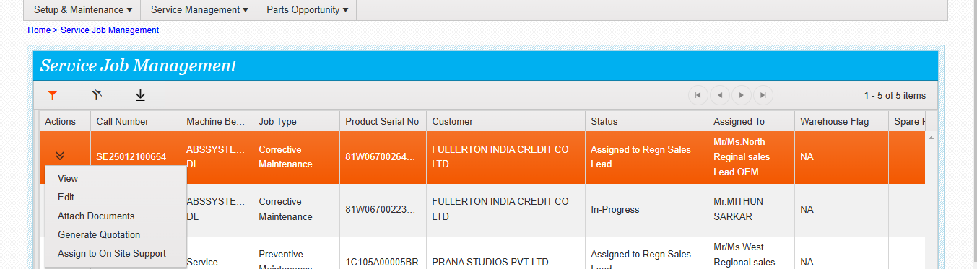When he clicks generate quotation the below screen will appear

Chargeable call flow

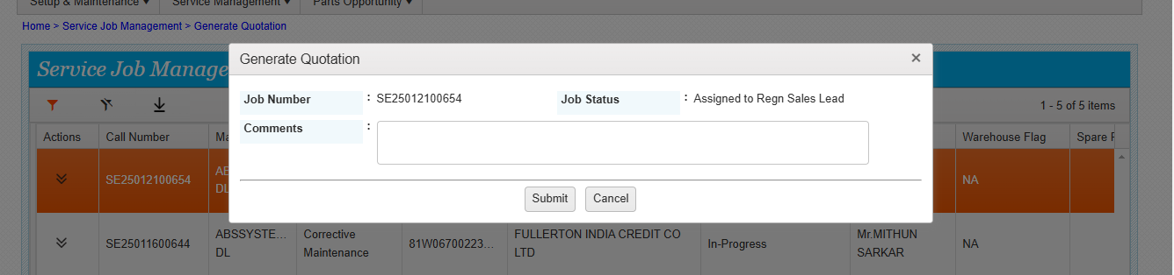

If he clicks assign to onsite support the below screen will appear

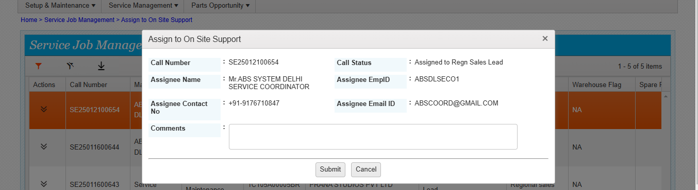

In two ways the Job can be assigned for onsite support by regional sales lead

Scenario 1 Generate quote -- customer order won – assign to onsite support

Scenario2 Directly assign the job for onsite support

If scenario 1 is followed by sales lead, then after assigning the job to onsite support the dealer service coordinator can do only assign the job to engineer

If scenario 2 is followed by sales lead, then after assigning the job to onsite support the dealer service coordinator can do quote submit action and customer order won and then assign the job to engineer.

Service job assigned for onsite support

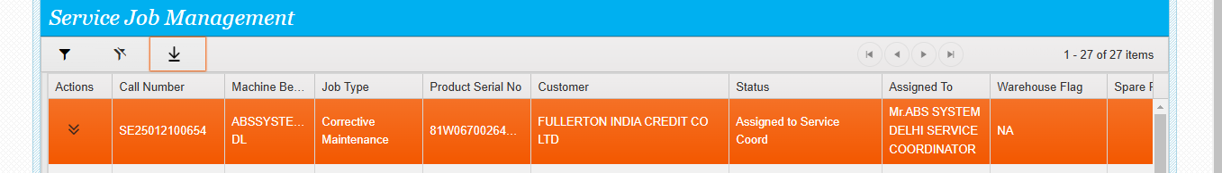

Chargeable call flow

The job is assigned to dealer by sales lead without submitting the quote from delta so dealer can see the quote submit action along with the assign option. He can do assign action directly or submit the quote, get the order and then assign the job to engineer. Both are possible.

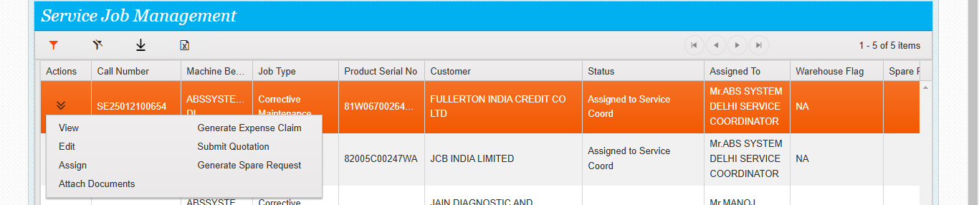

Dealer coordinator does quote submit action then the below screen will appear. He has to enter the details. Once the details are submitted then the status of the call will be changed to quote submitted.

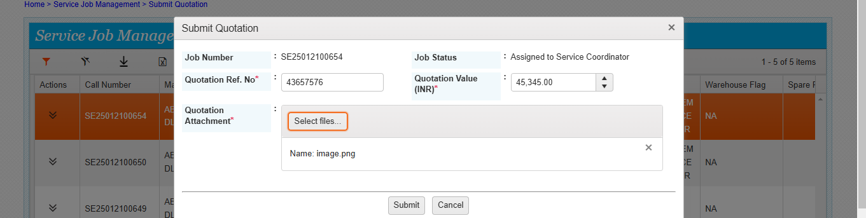

Submit quote done by dealer service coordinator

Chargeable call flow

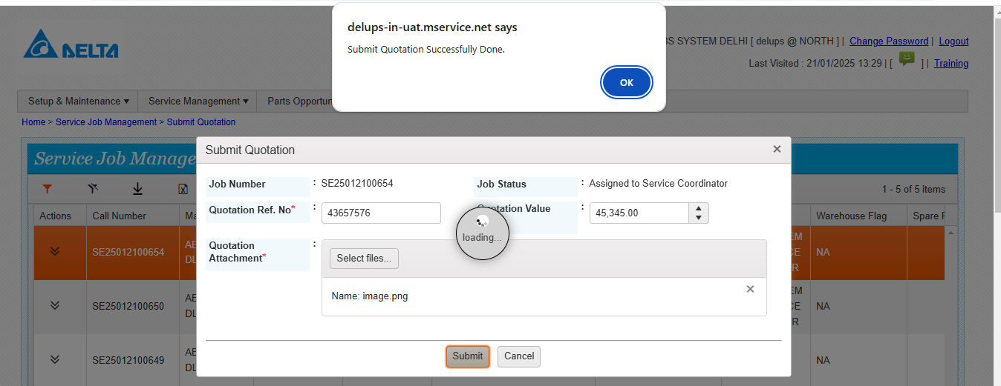

The status changed to quote submitted

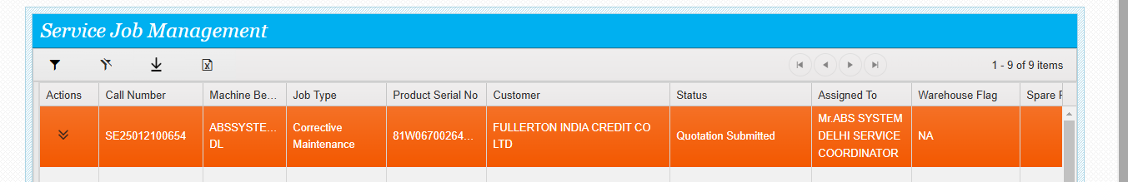

Next actions available for the dealer service coordinator /Do customer order won or lost

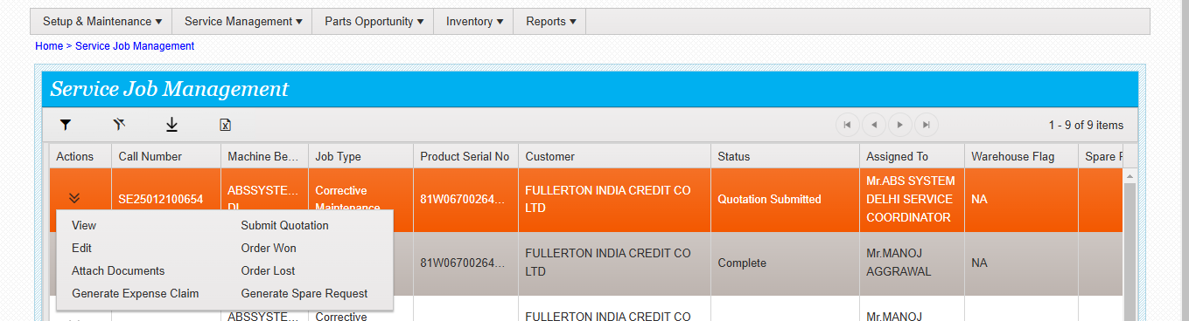

Chargeable call flow

When he clicks order won the below screen will appear

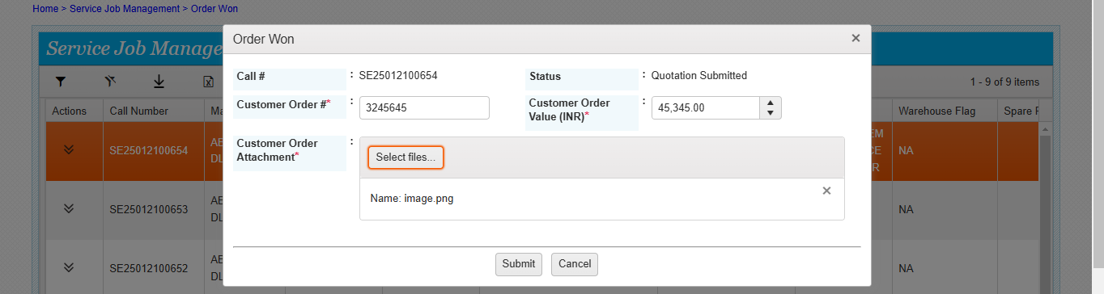Enter the details and submit. customer order won done successfully

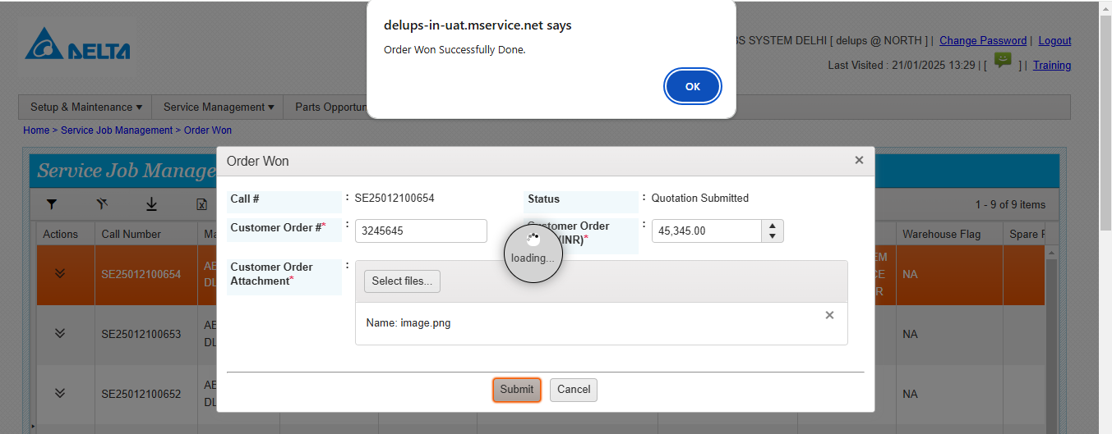The status is now customer accepted the quote.

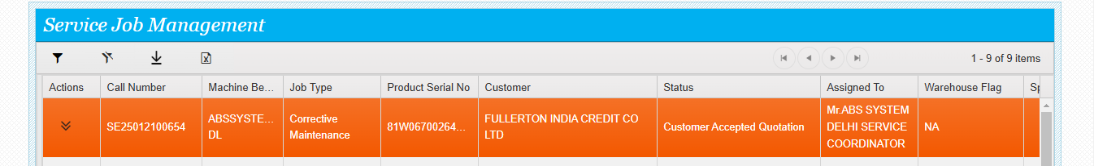

Chargeable call flow

Now the call can be assigned to dealer service engineer by clicking the assign action

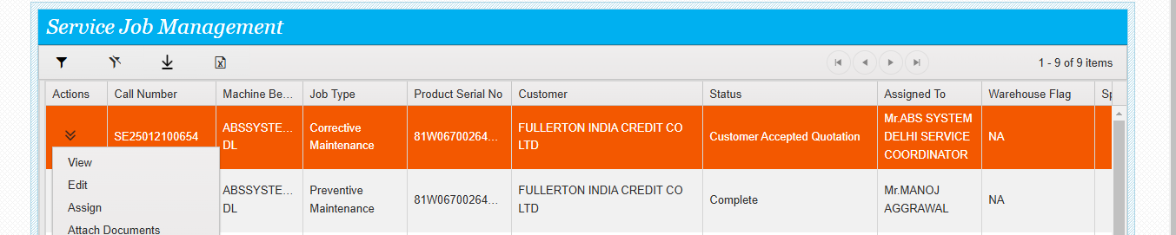

Now the call is assigned to the dealer service engineer

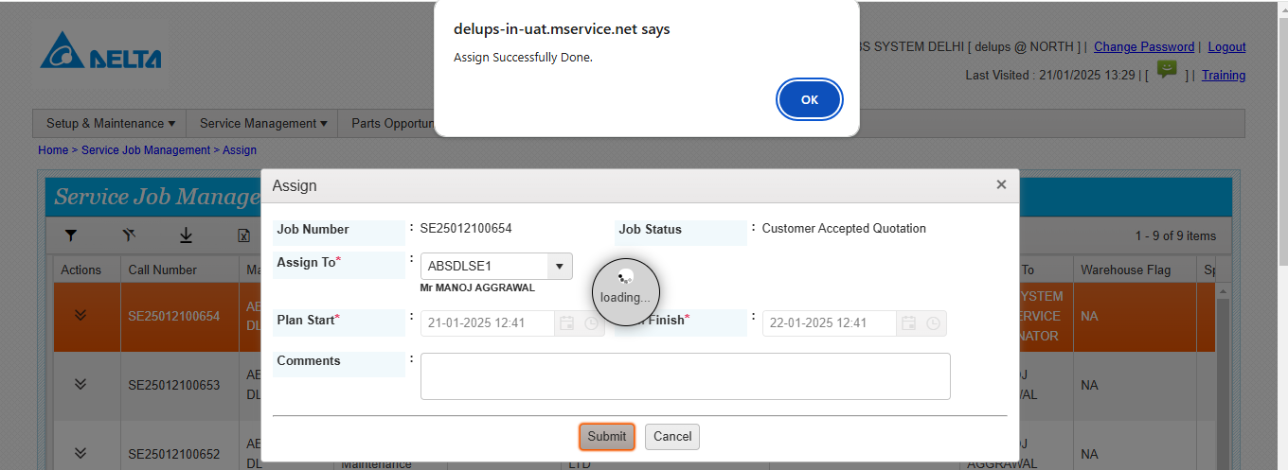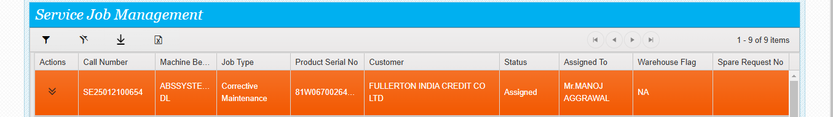

Engineer does the Mobile login and see the assigned calls in his mobile app Under My service call tab.

Chargeable call flow

Next action by engineer --- click trip start and click the tick mark, trip startedsuccessfully.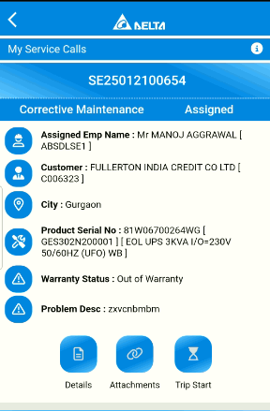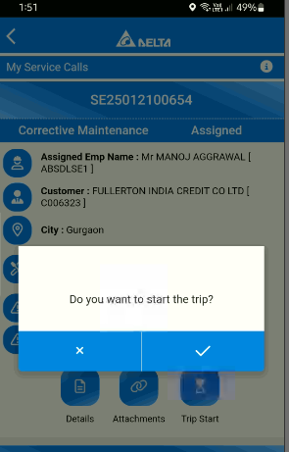

Chargeable call flow

Once the trip started is done then the service call will go to active mode. Next action trip finish is available, click trip finish, Trip finish done successfully.

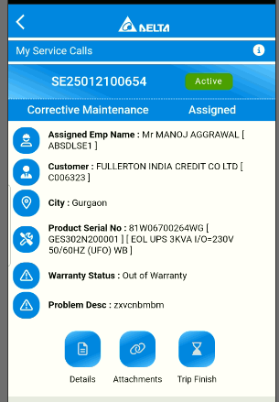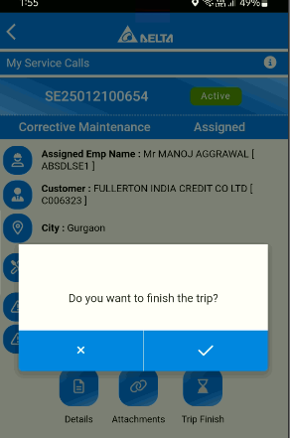

Chargeable call flow

Next action – Work start will appear, click on work start and click the tick mark, Work start done successfully.

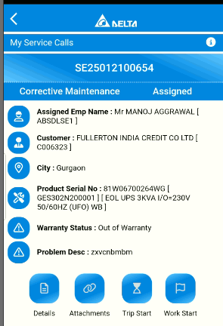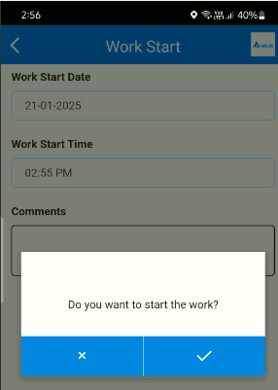

Chargeable call flow

Next action work finish will appear, click on work finish and click the tick mark. Work finish done successfully.

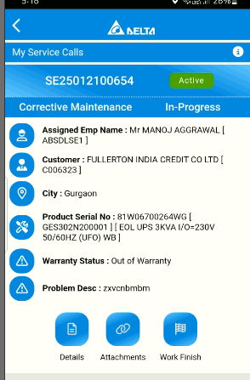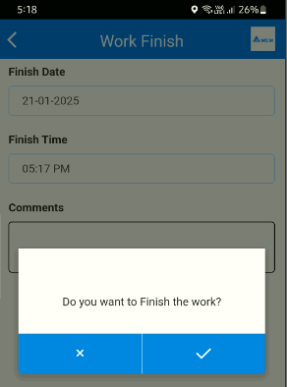

Chargeable call flow

Next actions available (DSR, FSR, TRIP START).

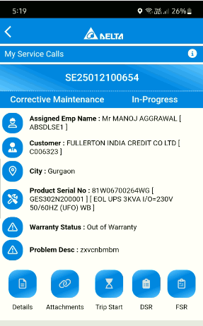

If any spares are required, then click DSR.

If the work is pending, engineers can also fill the DSR and continue the Job till it is getting closed.

Chargeable call flow

DSR -- Part recommendation, fill it and submit it DSR submitted successfully.

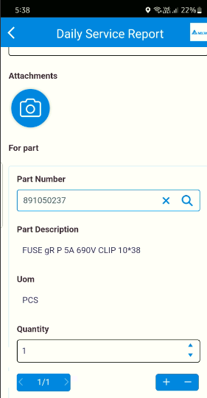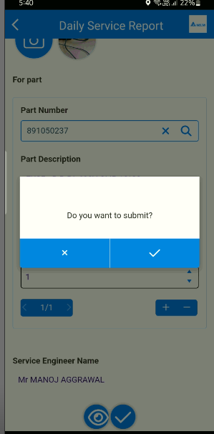

Chargeable call flow

Once DSR is submitted the next action will be only details and attachment. Once the queue is processed then the next action will appear.

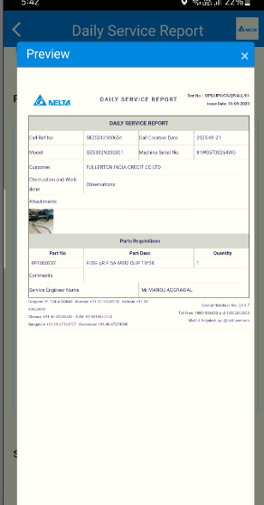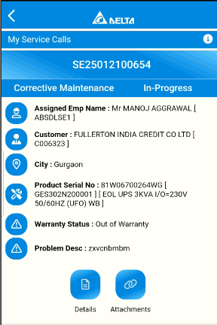

Chargeable call flow

Once the queue is processed then the next action will be available as below. The call status will be HOLD. PE ticket is generated and assigned to the respective coordinator for further action on it. but the call will remain with the engineer. If required, the call can be reassigned to some other engineer by service coordinator via web application.

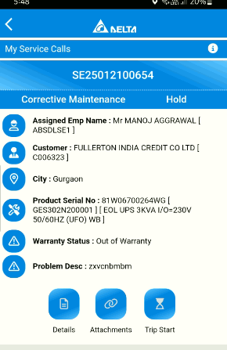

Engineers can do trip start and trip finish only during the call hold.

Chargeable call flow

Release Hold is available for service coordinator in web. Once the release hold is done by the coordinator engineer can do the work start and further process

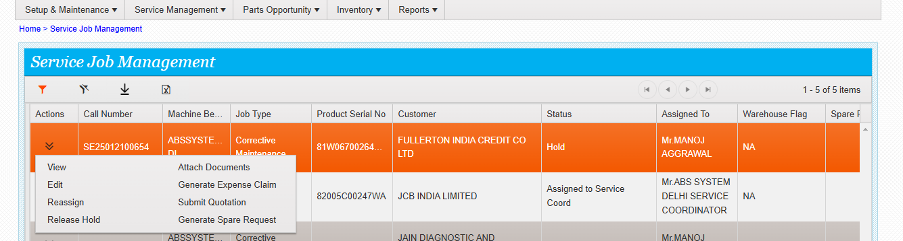

Release hold done successfully.

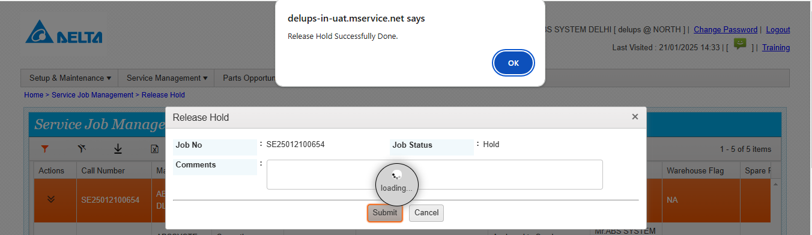

Now the call status is In progress

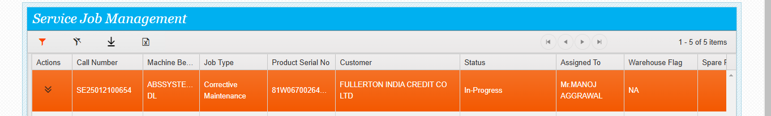

Chargeable call flow

In mobile also the call status is changed from Hold to in progress once it is refreshed.

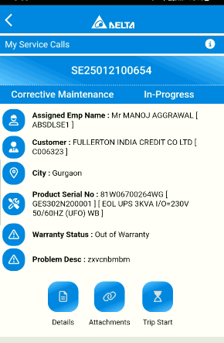

Do the trip start, Finish, Work start and work finish and submit DSR if any further spares required or else Submit the FSR .

Chargeable call flow

FSR Submitted successfully.

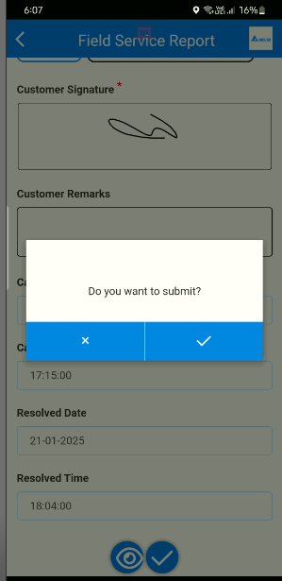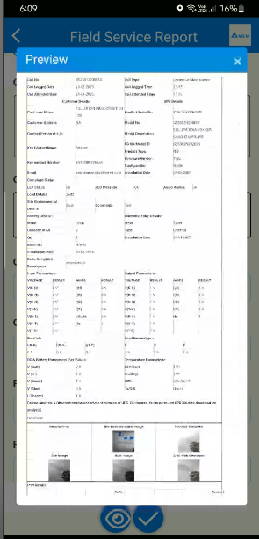

Chargeable call flow

Next action call complete. click call complete and click tick mark, Ccallcomplete done successfully.

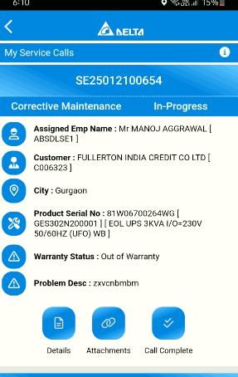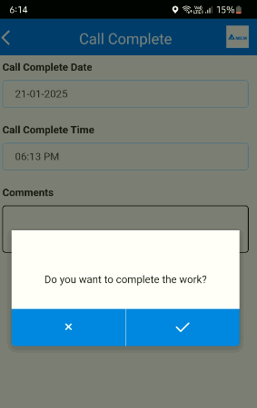

Chargeable call flow

Now the call status is Complete. Next action is trip start and trip finish.

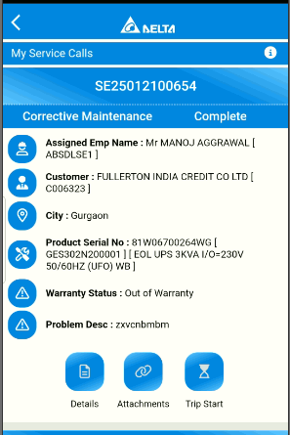

END